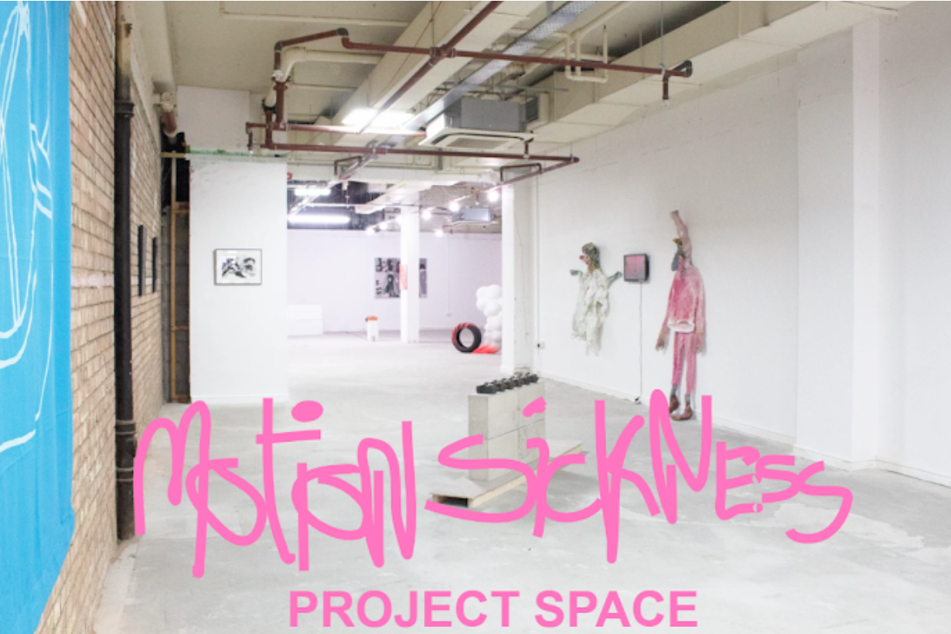
COMMITMENT: 7 hours a month plus attendance at quarterly meetings
We at Motion Sickness are looking to expand our team. We are scouting for people to work with us in areas including planning, outreach, artist liaison, fundraising, sponsorship, marketing and operations management.
This is an excellent opportunity for motivated early career artists or arts professionals to gain supported experience in all aspects of running an arts organisation.
ABOUT US
Since 2017, Motion Sickness have been dedicated to building a stronger and more connected art scene in Cambridge. Since 2019, we have been running our own project space which now has regional and national connections. Motion Sickness Project Space is the only space in Cambridge city center that is dedicated to supporting and exhibiting local and national emerging contemporary art. In the short time Motion Sickness have been operating, we have delivered talks, received an abundance of local and national press (FAD Magazine, Sluice, Cambridge Independent, Double Negative and Cambridge 105 radio etc.), as well as funding from Cambridge BID and Arts Council England.
We aim to specialise in showcasing emerging contemporary artists from low-income or working class backgrounds, including those from marginalised groups such as the LGBTQ community, those with disabilities, and Black, Asian and ethnically diverse artists. Therefore we are especially interested in hearing from people from these groups who would like to join the team.
ABOUT THE ROLES
The available roles are great opportunities for personal development and active self-learning, whilst connecting with and contributing to Cambridge’s cultural landscape. We will provide individuals with a sense of responsibility and ownership in running an arts organisation as part of a collective. Each volunteer will have the chance to voice their opinion and vote quarterly on upcoming programmes. You will play an active role in ensuring Motion Sickness Project Space runs smoothly and in a sustainable way.
We are committed to ensuring our team represents a diverse mix of skills and abilities. We seek applications from people from all backgrounds and experiences, and are actively encouraging applications from marginalised groups. If there is anything we can do to make this role more accessible, please let us know. If you would like to have an casual chat about any available roles, contact us at motion-sick@hotmail.com
Although we ask for volunteers to commit to around 7 hours per month, we are understanding of everyone's individual circumstances and realise that people's ability to commit to this role may change in line with their circumstances.
All positions will involve liaising with other members of the group so a collaborative attitude is essential for all roles. It is also crucial that all roles are filled with candidates who are passionate about diversifying the arts and must have an active anti-racist approach in their position. Here is a brief summary of each role we are recruiting for.
PAYMENT
Unfortunately we are a small volunteer artist-led organisation with no central funding at this time. We are currently unable to financially remunerate anyone (including ourselves) for work yet. However, we are committed to paying the artists we invite to exhibit with us, and this is achieved through project to project funding, but our ambition is to become more financially stable so that we can also offer payment to our gallery team.
LOGISTICS
This will include sourcing and organising equipment and dates for exhibitions. It will involve liaising with artists to clarify and source what they need. It may also include assisting in helping artists to find accommodation, or sourcing technical assistance for artists when mounting shows and organising refreshments for exhibitions. You will also need to compile data of audience numbers for exhibitions and events. People who are resourceful, organised, patient and passionate about art are encouraged to apply.
FUNDRAISING
This would suit someone who is interested and has previous experience in event organising. In the future, we are interested in developing this area to fund the space. In this role, you will develop ideas for and deliver income-generating activities. This could involve selling t-shirts, organising gigs/parties, art auctions or running an online shop. People with enthusiasm, organisational skills and creative fundraising ideas are encouraged to apply.
SPONSORSHIP
This will involve researching and reaching out to organisations to seek sponsorship. If successful , you will be responsible for maintaining relationships with sponsors. You will set out clear boundaries on what we as an organisation can offer to potential supporters. People who think outside the box and have excellent written communication skills are encouraged to apply.
OUTREACH LEAD
This will involve extending our outreach to marginalised members of the Cambridge community. Ideally, you will have experience in educational settings and community outreach but a demonstrated dedication to inclusive community engagement will be appreciated too.This role will involve actively networking and communicating with organisations already working with marginalised communities in Cambridge. You will help us identify how we as an arts organisation can be a resource for them. People who are organised, passionate about equality, excellent communication skills and thinking outside the box are encouraged to apply.
INVIGILATION LEAD
You will need to spearhead the active recruitment of invigilators and organise their schedules. You will also need to induct new candidates explaining their duties and required behaviour, as well as drafting the instructions for each exhibition eg. turning on projectors, lights or sculptures. The first morning after each exhibition opens, you will need to be at the space to instruct invigilators on how to turn works on and off. You will help us to find cover for shifts when invigilators cannot be there. You will also be in charge of coordinating the annual invigilators exhibition. People who are organised, sociable, dedicated and understanding are encouraged to apply.
LOCAL COMMUNITY DEVELOPMENT
Motion Sickness have previously hosted Playdate events which were bimonthly informal artist meetups organised to cultivate a community for cambridge artists. Events in the past have included artist speed dating, artist presentations, communal conversations, group crits and swapping of art materials. We are looking for people who are interested in expanding on our initial work. You will also spearhead our annual open call for Cambridge artists. People who are sociable, organised and creative are encouraged to apply.
MARKETING AND COMMUNICATIONS
Marketing and communications are crucial to building public awareness of Motion Sickness. You will take part in ensuring that all events and artistic activities are communicated across the appropriate channels to reach and engage a diverse audience. You will also be a champion for our artistic community on social media (Twitter, Instagram and Facebook), via our newsletter and partner networks. This role can be done remotely and you do not necessarily need to be Cambridge based. People with excellent communication skills and creative ability are encouraged to apply.
DESIGN/ CREATIVE BRANDING
This will involve creating posters for events and other creative content for Motion Sickness’ social media pages. You will have access and knowledge about Photoshop or other image making software. You will liaise with other members of the team to assess what is required. This role can be done remotely and you do not necessarily need to be Cambridge based. People with excellent design skills, a sense of fun and creative ability are encouraged to apply.
PERSON SPECIFICATION
- Some knowledge of using google drive
- An active interest in self-learning and personal development
- Ideally come from an arts or creative background
- Ability to commit to 7 hours a month with flexibility
- Dedication to the growth and development of the Cambridge arts community
- Committed, reliable and intuitive worker
- Excellent communicator, both in person and in writing
- A collaborative approach and the ability to work as part of a team is essential
- Flexible approach to sharing responsibilities and projects
- Ideally have a knowledge of contemporary art and other arts organisations
- Ideally creative with an ability to think outside of the box
- Some experience in planning and delivering arts projects, exhibitions or related events is desirable but not essential

HOW TO APPLY
Please send the following documents to motion-sick@hotmail.com with the role you are applying for in the subject line.
● A CV outlining your relevant experience ● A 500 words statement on which role you are interested in detailing why you are interested in the role/ what you have to offer/ ideas you have for the role ● Completed Equality and Diversity form (optional)

Equality and Diversity form

How did you find out about Motion Sickness?

Which age range do you fall into?
16 - 24
25 - 34
35 - 44
45 - 54
55 - 64
65+
Please indicate your gender identity? (e.g. female, male, non-binary)
Please indicate your sexual orientation?
Please indicate your ethnic origin?
Please indicate your religion or belief?
How would you describe your socio-economic background? (e.g. working class, middle class, upper class etc.)
Please indicate if you attended a state or fee-paying school between the ages of 11-18?

If you went on to study at University, were you part of the first generation of your family to do so?

Disability

The Equality Act 2010 defines a disabled person as someone who has a physical or mental impairment which has a substantial and long-term adverse affect on their ability to carry out normal day-to-day activities.

Do you consider yourself to be disabled?

